

**Semester One Examination 2017**

**Question/Answer Booklet**

**MATHEMATICS SPECIALIST**

**UNIT 1**

**Section Two:**

**Calculator-assumed**

Student Name: _____________________________________

Teacher’s Name: _____________________________________

**Time allowed for this section**

Reading time before commencing work: ten minutes

Working time for paper: one hundred minutes

**Material required/recommended for this section**

**To be provided by the supervisor**

This Question/Answer booklet

Formula Sheet (retained from Section One)

**To be provided by the candidate**

Standard items: pens(blue/black preferred), pencils(including coloured), sharpener, correction tape/fluid, erasers, ruler, highlighters

Special Items: drawing instruments, templates, notes on two unfolded sheets of A4 paper, and up to three calculators approved for use in the WACE examinations.

**Important note to candidates**

No other items may be taken into the examination room. It is **your** responsibility to ensure that you do not have any unauthorised notes or other items of a non-personal nature in the examination room. If you have any unauthorised material with you, hand it to the supervisor **before** reading any further.

**Structure of this paper**

|  |  |  |  |  |
| --- | --- | --- | --- | --- |
|  | Number of questions available | Number of questions to be attempted | Suggested working time (minutes) | Marks available |
| Section One  Calculator—free | 7 | 7 | 50 minutes | 50 |
| **Section Two**  **Calculator—assumed** | **12** | **12** | **100 minutes** | **100** |
|  | | | | 150 |

**Instructions to candidates**

1. The rules for the conduct of Western Australian external examinations are detailed in the *Year 12 Information Handbook 2017.* Sitting this examination implies that you agree to abide by these rules.
2. Answer the questions according to the following instructions.

Section Two: Write answers in this Question/Answer Booklet. Answer **all** questions.

**Show all your working clearly.** Your working should be in sufficient detail to allow your

answers to be checked readily and for marks to be awarded for reasoning. Incorrect

answers given without supporting reasoning cannot be allocated any marks. For any

question or part question worth more than two marks, valid working or justification is required to receive full marks. If you repeat an answer to any question, ensure that you cancel the answer you do not wish to have marked.

It is recommended that you **do not use pencil**, except in diagrams.

1. You must be careful to confine your responses to the specific questions asked and to follow any instructions that are specific to a particular question.
2. Spare pages are included at the end of this booklet. They can be used for planning your responses and/or as additional space if required to continue an answer.

* Planning: If you use the spare pages for planning, indicate this clearly at the top of the page.
* Continuing an answer: If you need to use the space to continue an answer, indicate inthe original answer space where the answer is continued, i.e. give the page number. Fill in the number of the question that you are continuing to answer at the top of the page.

1. The Formula Sheet is **not** handed in with your Question/Answer Booklet.

# Section Two: Calculator–assumed 100 marks

This section has **Twelve (12)** questions. Attempt **all** questions. Write your answers in the spaces

provided.

Working time: 100 minutes

**Question 8 (5 marks)**

Two rockets are fired simultaneously from the same point. Rocket A is travelling at 6 kms-1 on a bearing of 060°T while Rocket B is travelling at 8 kms-1 on a bearing of 120°.

Let **i** be a unit vector that points east and **j** a unit vector that points north,

Determine the projection of the path of Rocket A onto the path of Rocket B in the format a**i** + b**j**, with a and b in exact format.

Draw a diagram to support your answer.

(5 marks)

**Question 9 (7 marks)**

Quadrilaterals are to be formed with the dots below as vertices, using two dots from the top row and two dots from the bottom row. One such example is shown.

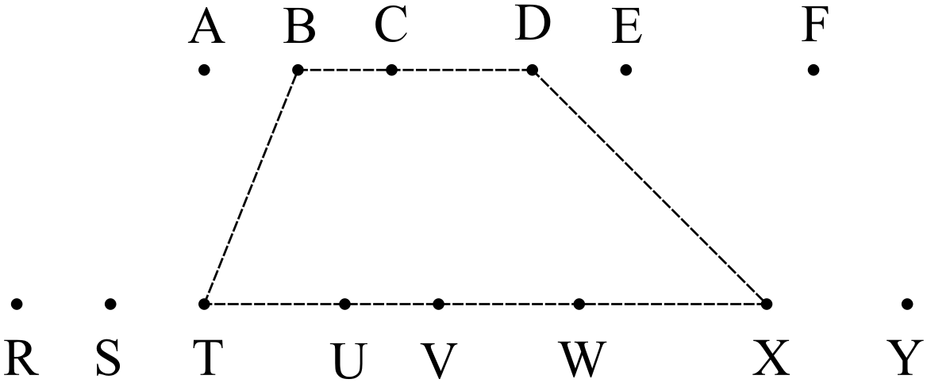

(a) How many different quadrilaterals can be formed? (2 marks)

(b) How many of the quadrilaterals in (a):

(i) do not have C as a vertex? (2 marks)

(ii) do not have C as a vertex nor contain C in the uppermost side? (3 marks)

**Question 10 (8 marks)**

(a) Show that 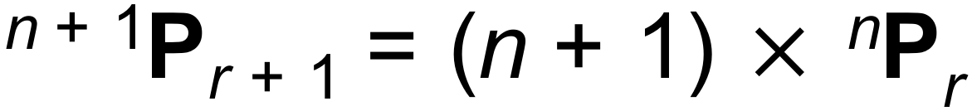 , where n, r 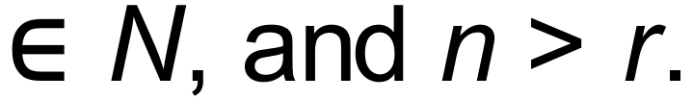 (3 marks)

(b) The digits from the set {1, 2, 3, 4, 5, 6, 7} are used to form 4-digit PIN numbers without repetition.

(i) How many 4-digit PIN numbers can be formed? (1 mark)

(ii) How many of the numbers in (i) are less than 5 000? (2 marks)

(iii) How many of the PIN numbers in (i) are even? (2 marks)

**Question 11 (11 marks)**

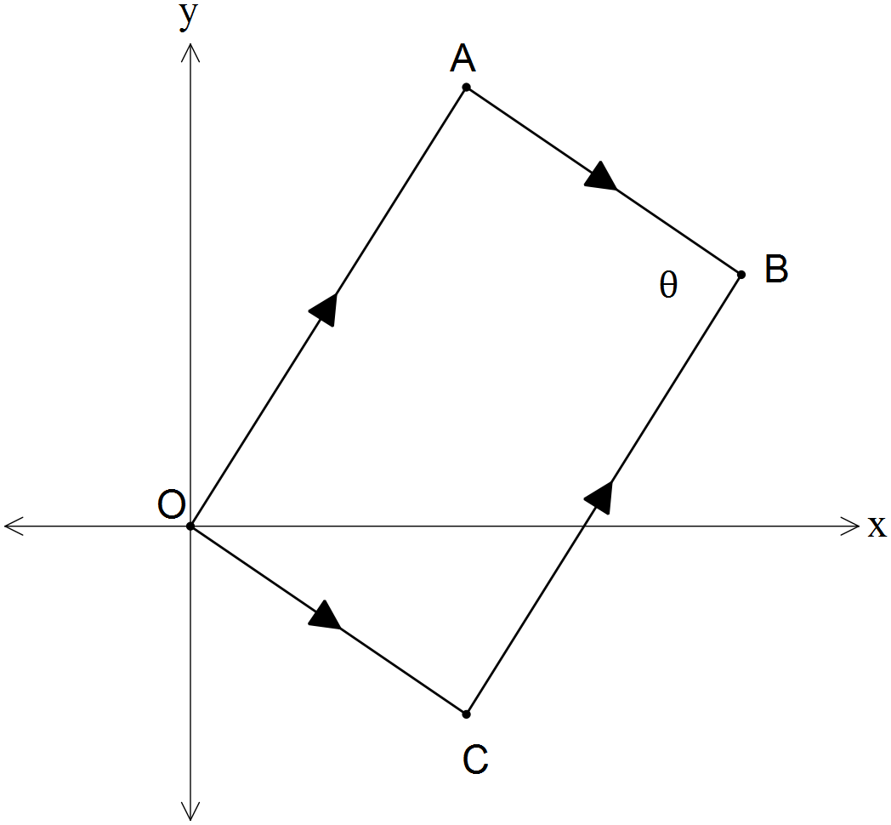OABC is the parallelogram shown with vectors

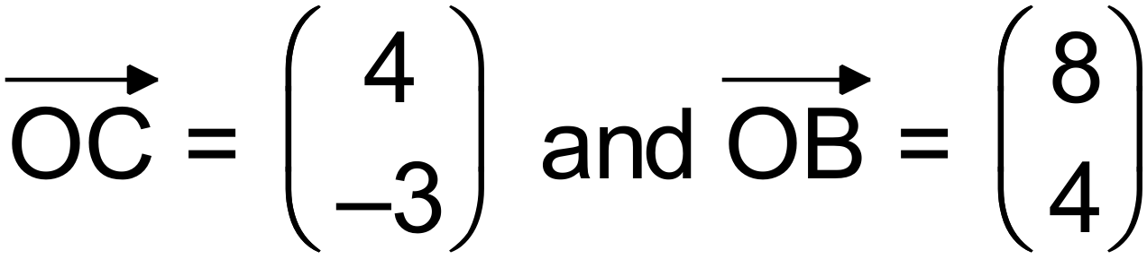.

(a) State the vectors 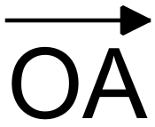 and 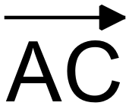. (2 marks)

(b) Show that the diagonals OB and AC bisect each other. (4 marks)

**Question 11 (Continued)**

(c) Use the scalar product to show that 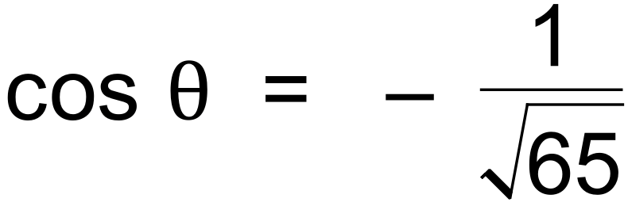 (2 marks)

(d) Using your answer in (c) determine the exact value of 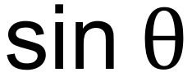. (1 marks)

(e) Use your answer in (d) to determine the exact area of parallelogram OABC. (2 marks)

**Question 12 (11 marks)**

(a) Consider the following statement: 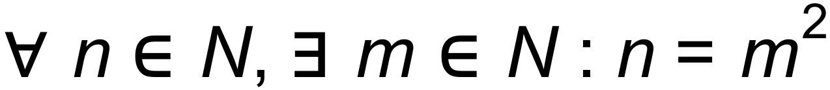

(i) Rewrite the statement in words. (3 marks)

(ii) Provide a counter example, explaining your choice. (1 mark)

(b) Determine whether the statements below satisfy the relationship A $⇔$ B, by considering

the validity of both A $⇒$ B and B $⇒$ A.

A: The quadrilateral has two pairs of parallel sides.

B: The quadrilateral is a rhombus. (3 marks)

**Question 12 (Continued)**

(c) Consider the following statement.

“If a triangle inscribed in a circle has the diameter as one of its sides, then the triangle is right angled”.

(i) State the converse of the statement. (1 mark)

(ii) Is the converse valid? Explain. (1 mark)

(iii) State the contrapositive of the statement. (1 mark)

(iii) Is the contrapositive valid? Explain. (1 mark)

**Question 13 (10 marks)**

Tugboats are small vessels used to manoeuvre large ships in a dock by pushing or pulling them.

Three tugboats A, B and C are used to manoeuvre a large container ship out of its dock as shown.

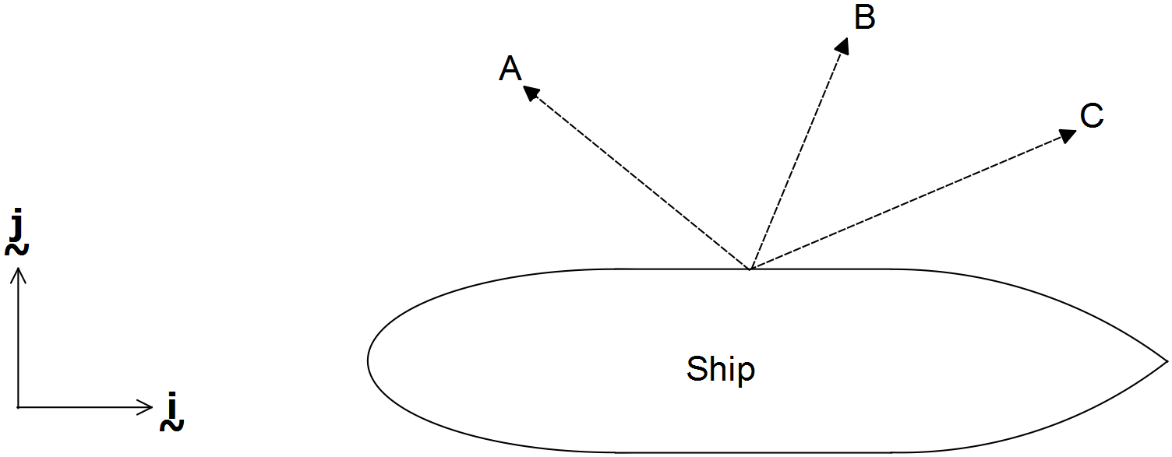

Tugboat A is pulling with a force of 1200 N on a bearing of 310°T, while tugboat C is pulling with a force of 1000 N on a bearing of 040°T.

(a) If tugboat B is pulling with a force of 800 N due North, determine the magnitude of the overall force exerted by the three tugboats on the vessel, and the bearing in which the vessel moves.

Show your working clearly.

(6 marks)

**Question 13 (Continued)**

To manoeuvre the ship safely out of the dock it was determined that it should move due North and that the overall force of the three tugboats must not exceed 3000 N.

(b) Determine the bearing that tugboat B should use to pull the vessel due north and the

maximum pulling force to do it safely. (4 marks)

**Question 14 (8 marks)**

(a) Use proof by contradiction to show that if n is odd, 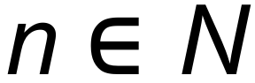, then 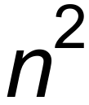 is odd. (4 marks)

(b) In the diagram below ABCD is a cyclic quadrilateral and O is the centre of the circle.

Let . Prove that  and 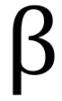 are supplementary. (4 marks)

Under what conditions would 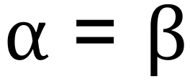?

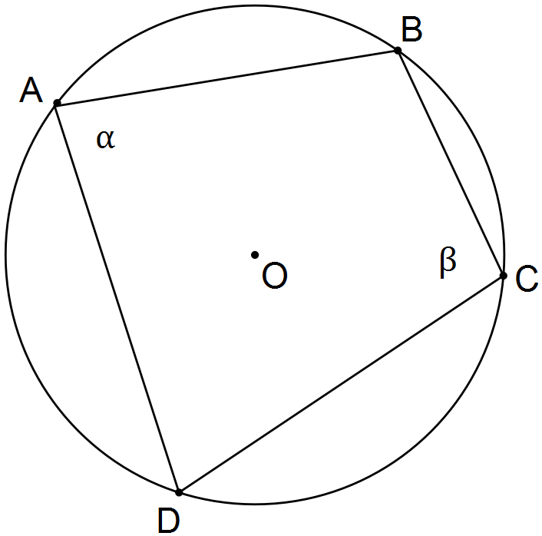

**Question 15 (7 marks)**

ABCD is a quadrilateral with vertices 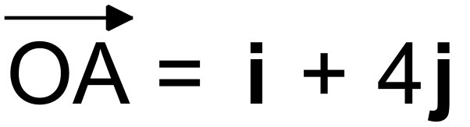, 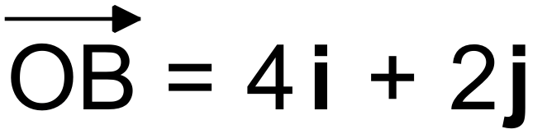, 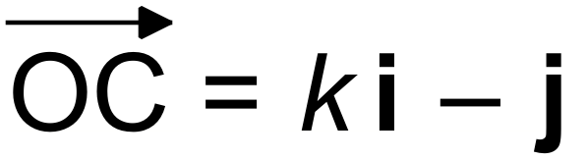 and 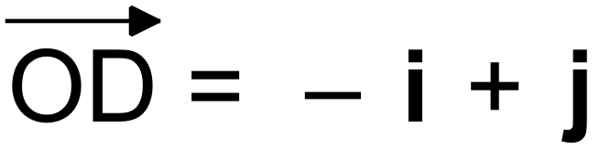, with 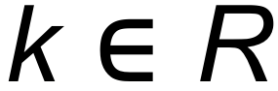. O is the origin.

(a) Determine the diagonals 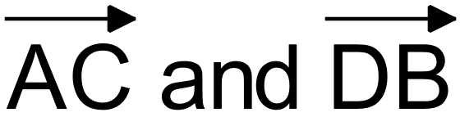 in terms of k where applicable. (2 marks)

(b) Given that ABCD is a rhombus, determine the value of k. (2 marks)

(c) When k = 2, ABCD is a parallelogram. Use ABCD to show that the sum of the squares

of the lengths of the diagonals of a parallelogram is equal to the sum of the squares of

the lengths of the sides. (3 marks)

**Question 16 (11 marks)**

Perth Western Australia is 9000 km from Dubai, on a bearing of 132°. An Airbus A380 flies from Dubai to Perth weekly. It can cruise in still air at 945 km/h.

The average cruising altitude of this flight is 43000 ft, and at this height the wind can reach an average speed of 150 km/h. On a particular day, the plane encounters a wind coming from a bearing of 020°T.

(a) On the axes below, draw a vector diagram of the situation, clearly showing how the

parallelogram method is used to find the resultant velocity in the required direction. (3 marks)

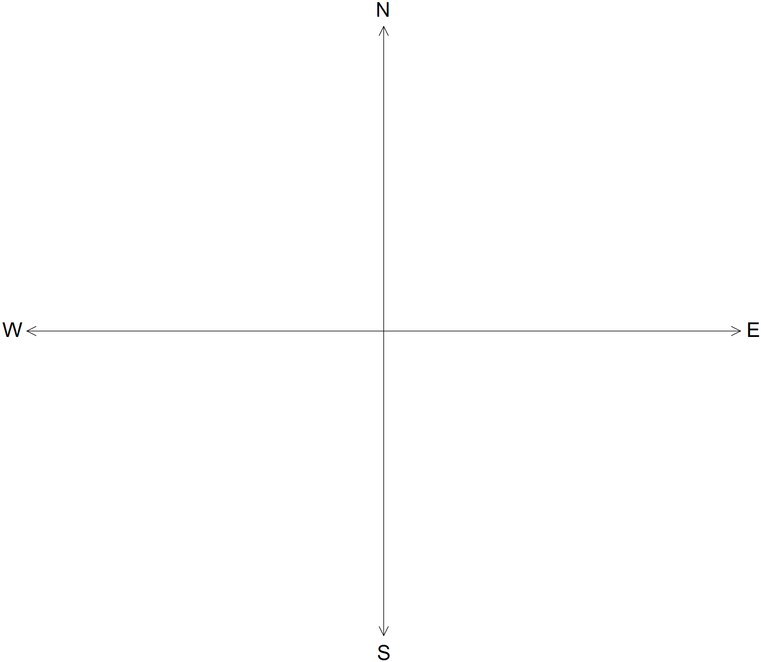

(b) From your sketch above, label the diagram below to show how triangle trigonometry

can be used to solve this problem. (2 marks)

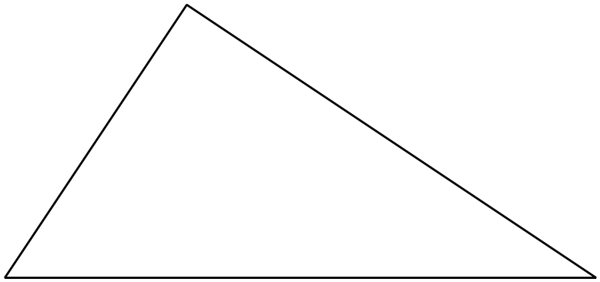

**Question 16 (Continued)**

(c) Assuming that the wind speed and the direction remain constant for the duration of the flight, use triangle trigonometry to determine the flight duration as well as the bearing the pilots should set to overcome the effects of the wind, and fly to their destination in a direct line.

(6 marks)

**Question 17 (6 marks)**

The points A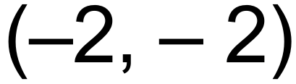, B(1, *y*) and C(*x*,1) are collinear.

Given that point B divides internally the line segment AC in the ratio AB : BC = 1 : 2,

determine *x* and *y*. (6 marks)

**Question 18 (7 marks)**

(a) Solve for x: 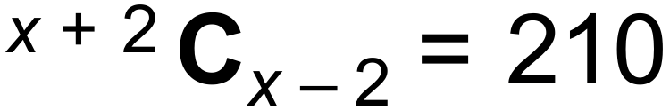 (3 marks)

(b) Prove that 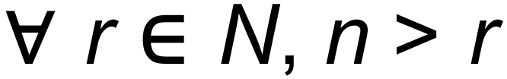: 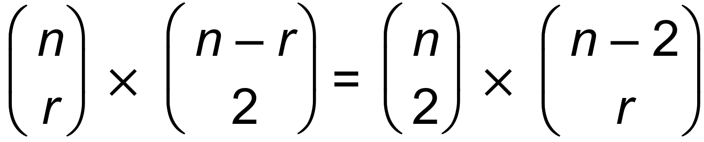 (4 marks)

**Question 19 (9 marks)**

The diagram below shows a semicircle where O is the centre of the complete circle.

Chords AB and CD intersect at P such that AP:PB = 2:1 and |PD| = 5 cm.

EF is tangent to the semicircle with |EF| 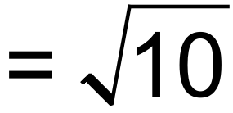 cm. Points A, P, B and F are collinear, with |BF| = 1 cm.

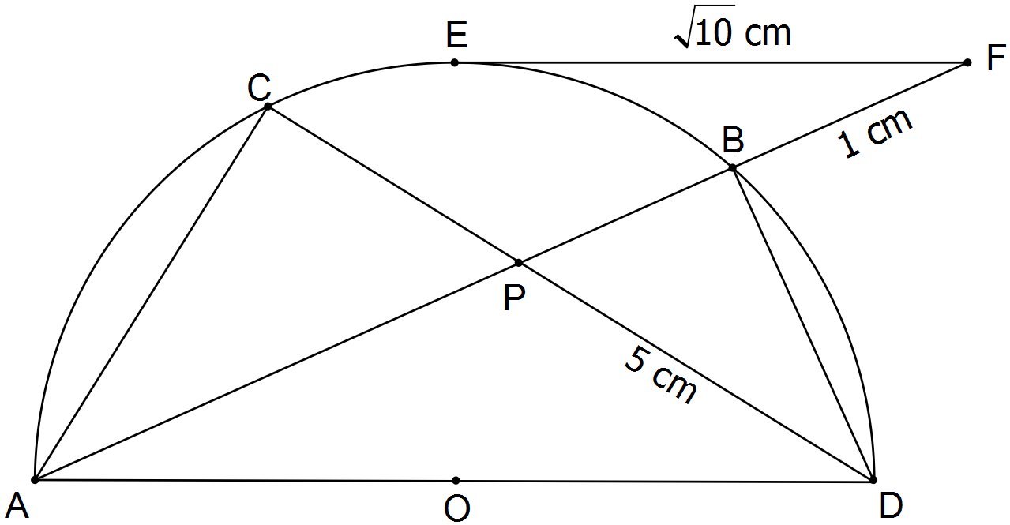

(a) Use an appropriate theorem to determine |AB|. (2 marks)

(b) Use an appropriate theorem to determine |CD|. (3 marks)

**Question 19 (Continued)**

(c) Show, with reasons, why |BD| = 4 cm. (2 marks)

(d) Determine the radius of the circle. (2 marks)

**END OF QUESTIONS**

**Additional working space**

Question number(s): ……………………

**Additional working space**

Question number(s): ……………………

**Additional working space**

Question number(s): ……………………

**Additional working space**

Question number(s): ……………………

WATP acknowledges the permission of School Curriculum and Assessment Authority in

providing instructions to students.